Ideation Phase
Empathize & Discover
Date | 23 September 2026
Team ID | [Enter Team ID]
Project Name | Streamlining IT Procurement: Automating Standard Laptop Orders with Flow Designer
Maximum Marks | 4 Marks

Empathy Map Canvas:
An empathy map is a simple, easy-to-digest visual that captures what a user thinks, feels, hears, sees, says and does. It helps the team step into the shoes of the person facing the problem, understand their goals and frustrations, and design a solution that truly addresses their needs rather than just the surface symptoms.
For this project, the primary user affected by the current manual procurement process is a new employee waiting on a standard laptop. The empathy map below captures their experience before the Flow Designer automation is introduced.
Persona: New Employee Requesting a Standard Laptop
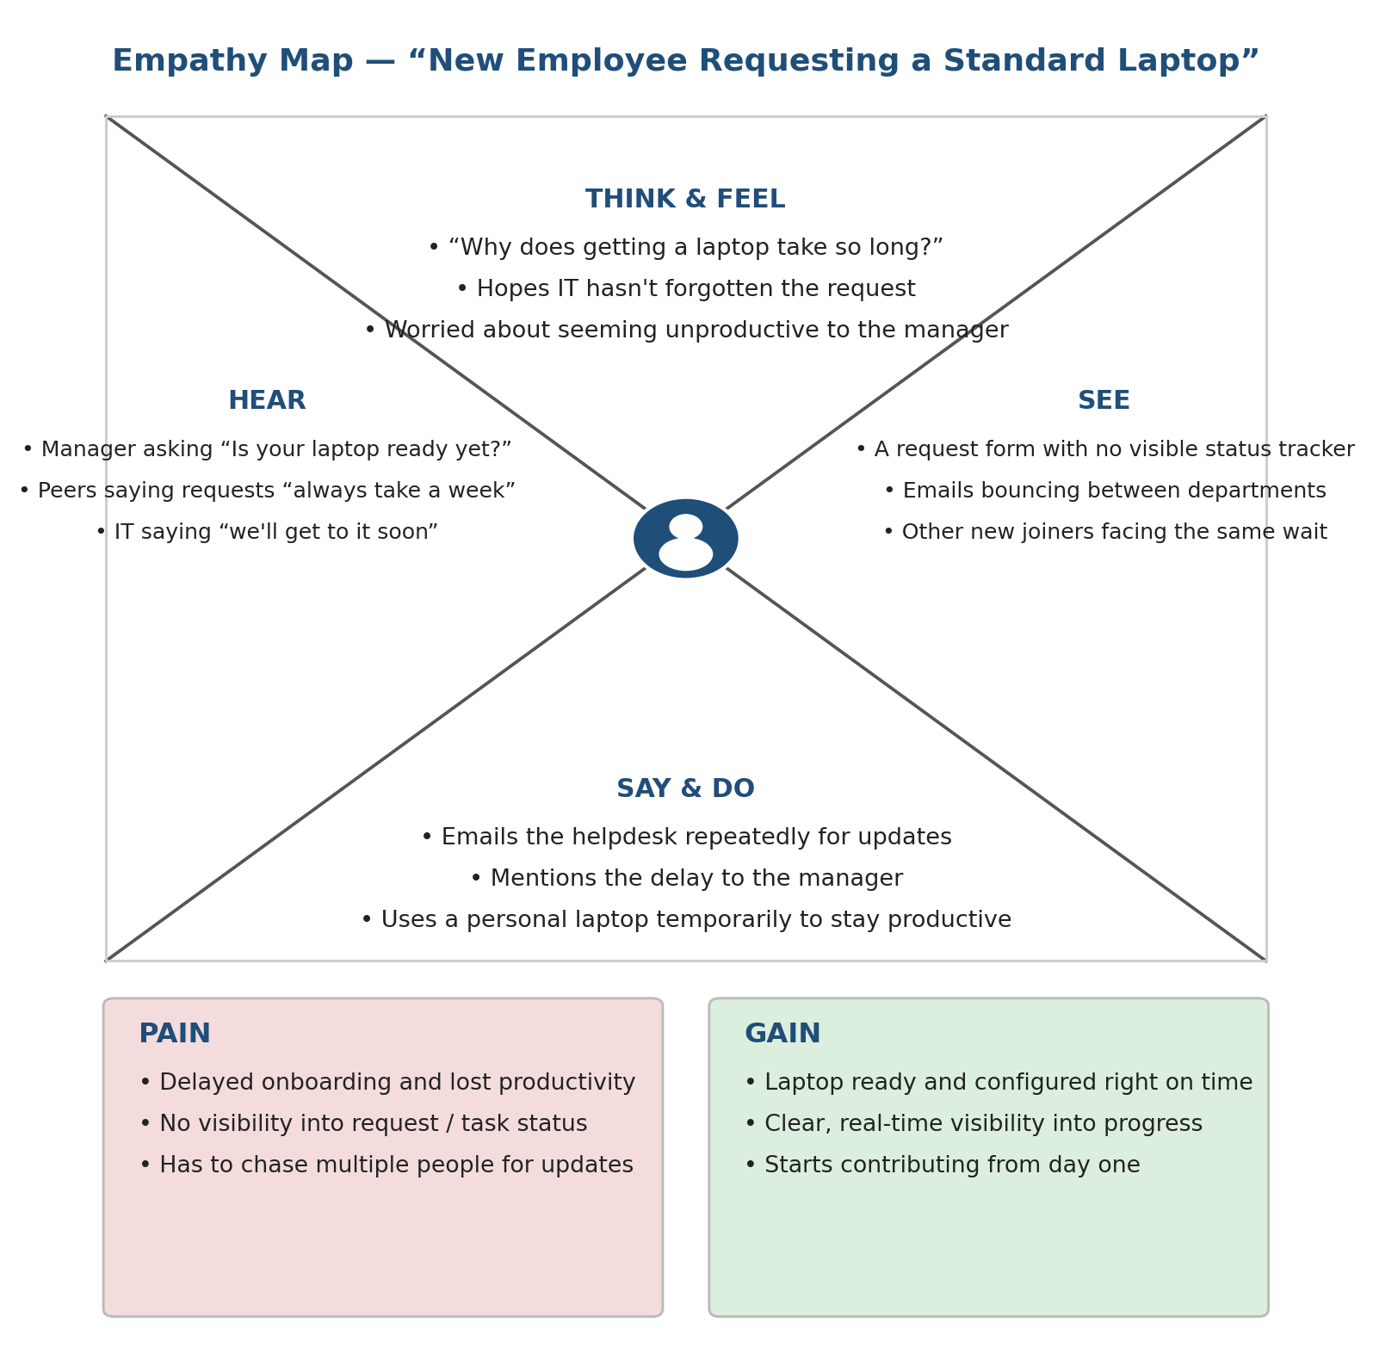
This empathy map directly supports the project's problem statement: the requester's frustration and lost productivity stem from a lack of visibility and automatic handoff between the approved request and the Hardware team's configuration task — exactly the gap the Flow Designer solution is built to close.
Reference: https://www.mural.co/templates/empathy-map-canvas

